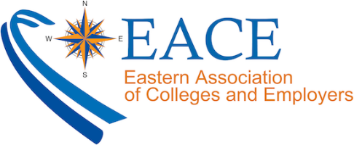

EACE20 Gain Approval Letter

To: (Insert manager’s name here)

From: (Insert your name here)

Subject: EACE 2020 Annual Conference

The EACE 2020 Annual Conference features strong programming and the unparalleled opportunity to connect with more than 400 of the field’s most active college student recruiters and career services professionals. By attending this conference, I can gain fresh ideas, skills, and contacts that will benefit (insert name of organization/institution here).

I believe attending EACE20 will allow me to:

- Bring back new ideas and best practices that will immediately benefit our operation

- Choose from 35+ educational workshops to stay on top of trends that could affect our operation and goals, and identify strategies to capitalize on trends in our industry

- Build new and strengthen existing relationships that will benefit our office

- Attend a highly ranked and established conference for a fraction of the cost of NACE

I believe this will be a great investment for (insert your company name here) and a good use of my time.
When I return to the office, I’ll share my takeaways with the team, including the ones we can implement immediately and an action plan for how we can make that happen.

Below is a breakdown of approximately how much it will cost for me to attend EACE20:

- Airfare/Travel: [CALCULATE AIRFARE PRICE]
- Hotel: [CALCULATE HOTEL PRICE] - $169 + tax per night at the Baltimore Marriott Waterfront while group block vacancy is still available]
- Event Registration: $429 [MEMBER RATE FULL CONF] through April 30th
- TOTAL: [CALCULATE TOTAL]

Please note, the earlier I register, the cheaper it will be. By securing the current offer, we can save hundreds of dollars on overall expenses.

To learn more about EACE20, feel free to visit eace.org. Thank you for taking the time to review this request, and I look forward to talking to you more about it soon!
Best Regards,

(insert your name here)

